HTML Quick-Styler

AI-Powered HTML Page Generator with IBM Granite 3.3 2B

Team Leader: S.Esai dharshini - 5823128009
Team Members :
- S.Dhara - 5823128007
- G.Dharani -5823128008
- D.Gokula preethika -5823128010
- B.Deepa Sri - 5823128006

Project Description

HTML Quick-Styler is an intelligent web page generation platform that leverages IBM's Granite 3.3 2B Instruct model to provide comprehensive HTML/CSS page creation with professional styling and responsive design. The platform addresses the challenge of rapid web development by delivering AI-powered HTML generation, automatic section detection, modern CSS styling, color palette management, and production-ready code output.
Using Granite 3.3 2B's advanced language capabilities, the system analyzes user descriptions — page title, section requirements, and color preferences — then generates semantic HTML structure, applies modern CSS styling with animations, creates responsive layouts, and provides multiple color palette options. The system ensures professional output through Gradio's user-friendly interface while maintaining high-quality design standards through sophisticated template generation and AI-powered content suggestions.
HTML Quick-Styler transforms web development into an intelligent, user-friendly experience. Its modern Gradio interface, comprehensive feature set, and AI-powered analysis deliver personalized HTML pages that respect design trends, accessibility standards, and responsive design principles.

Scenarios
Scenario 1: Portfolio Website Generation
A freelance designer wants to create a professional portfolio website quickly and efficiently. The system first detects the project requirements and analyzes the designer's style and design preferences. Based on this understanding, it generates a complete website structure that includes a visually appealing hero section with a welcoming message and a strong call-to-action to engage visitors immediately. It also builds a responsive portfolio gallery arranged in a clean grid layout to showcase projects effectively across devices. An about section is created to present the designer's professional bio in a compelling manner, helping visitors understand their background and expertise. To strengthen credibility, the system includes a testimonials section featuring client feedback. A contact form with proper input validation ensures smooth communication while preventing errors, and finally, a professional footer is added with social media links and essential information to complete the polished look of the website.

Scenario 2: Sad Landing page
A startup needs a powerful landing page for launching their new product. The system responds by creating a compelling hero banner that clearly communicates the product's value proposition and key messaging. It then generates a features showcase section, presenting product capabilities with visually appealing icons and concise descriptions to make the benefits easy to understand. A pricing comparison table is designed with clear plan options to help potential customers make informed decisions. To build trust and credibility, the system incorporates a testimonials section that highlights positive user experiences and social proof. Prominent and strategically placed call-to-action buttons are added throughout the page to guide visitors toward signing up or purchasing, ensuring strong conversion optimization.

Scenario 3: Corporate Website
A company requires a professional corporate website with multiple structured sections. The system delivers a clean and polished layout starting with a sticky navigation header that includes company branding and allows smooth navigation across sections. It creates a company overview section that clearly communicates the organization's mission, vision, and core values. A services grid is generated to present detailed descriptions of the company's offerings in an organized and visually structured manner. The website also includes a team members section with photos and short profiles to add a human touch and build trust with visitors. Additionally, a contact section is implemented with company information and an inquiry form for seamless communication. The site is completed with a professional footer containing privacy policies and important links, ensuring a corporate-standard presentation.

Scenario 4: Custom Color Palette Exploration
A designer wants to experiment with different color schemes to find the perfect visual identity for their project. The system generates eight carefully curated pre-designed color palettes, including modern, vibrant, ocean, forest, sunset, luxury, creative, and minimal themes. Each palette comes with clearly defined hex color codes for every component, making implementation straightforward and precise. The system provides a real-time preview feature, allowing the designer to instantly visualize how each color scheme affects the overall design and feel of the page. It ensures consistent color application across all page elements to maintain visual harmony throughout the entire layout. Additionally, dark theme-optimized backgrounds are included to support modern design trends and improve user experience in low-light viewing environments.

Architecture Overview

HTML Quick-Styler is built as a modular platform combining a Python backend with IBM Granite 3.3 2B Instruct model for intelligent HTML generation. The architecture prioritizes user experience, design quality, and code production through Gradio's interactive interface and sophisticated template generation. The system is structured around three core classes — ColorPaletteGenerator, HTMLPageBuilder, and the CSS Generation Engine — each handling a specific aspect of the page creation pipeline. These components work together seamlessly to take a user's plain-language description and transform it into fully styled, production-ready HTML code within seconds.
Core Technologies
- Python 3.x serves as the core programming language handling all application logic, class definitions, and pipeline orchestration.
- IBM Granite 3.3 2B Instruct is the AI model responsible for intelligent, context-aware HTML and CSS content generation based on user inputs.
- Gradio provides the interactive web interface framework that powers the 5-tab user interface through which users interact with the system.
- HTML5 and CSS3 are the modern web standards used as the output format for all generated pages.
- JavaScript handles client-side interactivity, smooth scrolling, and animation effects in the output pages.
- Google Colab serves as the cloud-based development and deployment environment that provides free GPU and TPU resources.
- Responsive design is implemented throughout using a mobile-first approach with CSS media queries, Flexbox, and CSS Grid.

Pre-requisites

Software Requirements
• Python 3.8+: Download from python.org
• Google Account: Required for Google Colab access
• Gradio: Install via pip (pip install gradio)
• Web Browser: Chrome, Firefox, Safari, or Edge
• Internet Connection: Required for Colab and model access

Knowledge Prerequisites
• Python Basics: Functions, classes, dictionaries, string manipulation
• HTML/CSS: Understanding of HTML structure and CSS styling
• Gradio Framework: Basic understanding of interface components
• Web Design: Color theory, responsive design principles
• Google Colab: Familiarity with notebook interface

Hardware Requirements
• Processor: Intel i3 or equivalent (Colab runs on cloud)
• RAM: Minimum 4GB local (Colab provides GPU/TPU)
• Storage: 1GB free space for generated files
• Display: Minimum 1280x720 resolution for interface
Project Workflow

Phase 1: Environment Setup & Model Configuration
Establish Google Colab environment and configure Granite model

Activity 1.1: Set up Google Colab Environment
• Create new Google Colab notebook
• Enable GPU runtime for better performance
• Install required Python packages
• Verify environment configuration

Activity 1.2: Configure IBM Granite Model
• Access Hugging Face model repository
• Load Granite 3.3 2B Instruct model
• Test model inference capabilities
• Configure generation parameters

Activity 1.3: Install and Configure Gradio
• Install Gradio via pip
• Test basic Gradio interface
• Configure sharing options
• Verify interface rendering
Phase 2: Core Application Development
Build HTML generation engine and template system

Activity 2.1: Build Color Palette Generator
• Create ColorPaletteGenerator class
• Define 8 color palette schemes
• Implement palette selection logic
• Add color validation methods

Activity 2.2: Implement HTML Page Builder
• Create HTMLPageBuilder class
• Build section detection algorithm
• Implement template generation methods
• Create SEO meta tags generator

Activity 2.3: Develop CSS Generation Engine
• Build comprehensive CSS generator
• Implement responsive design rules
• Add animation and transition effects
• Create mobile-first media queries

Activity 2.4: Build Section Templates
• Create hero section template
• Build features grid template
• Implement portfolio gallery template
• Add contact form template
• Create pricing and testimonial templates
Phase 3: Gradio Interface Development
Create interactive user interface with multiple tabs

Activity 3.1: Interactive HTML Generation & Preview Interface
Activity 3 focuses on designing and implementing a complete HTML generation and visualization interface that enables users to create, customize, preview, and understand web page layouts through an intuitive, multi-section workflow.
Phase 4: Google Colab Deployment:
Integrate all components and perform comprehensive testing

Activity 4.1: End-to-End Integration
• Connect all interface components
• Test data flow between tabs
• Validate generation pipeline
• Test error handling
Phase 5: Deployment & Documentation
Deploy application and create comprehensive documentation

Activity 5.1: Functionality testing
• Configure Gradio sharing settings
• Enable public access link
• Test external access
• Document deployment steps

Technical Architecture
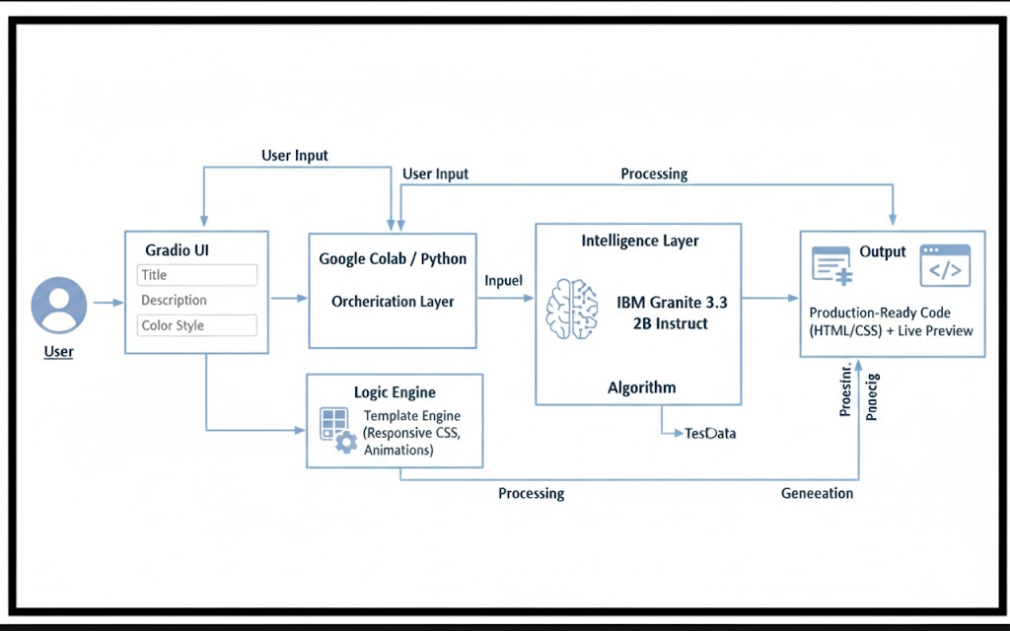

Project Structure:
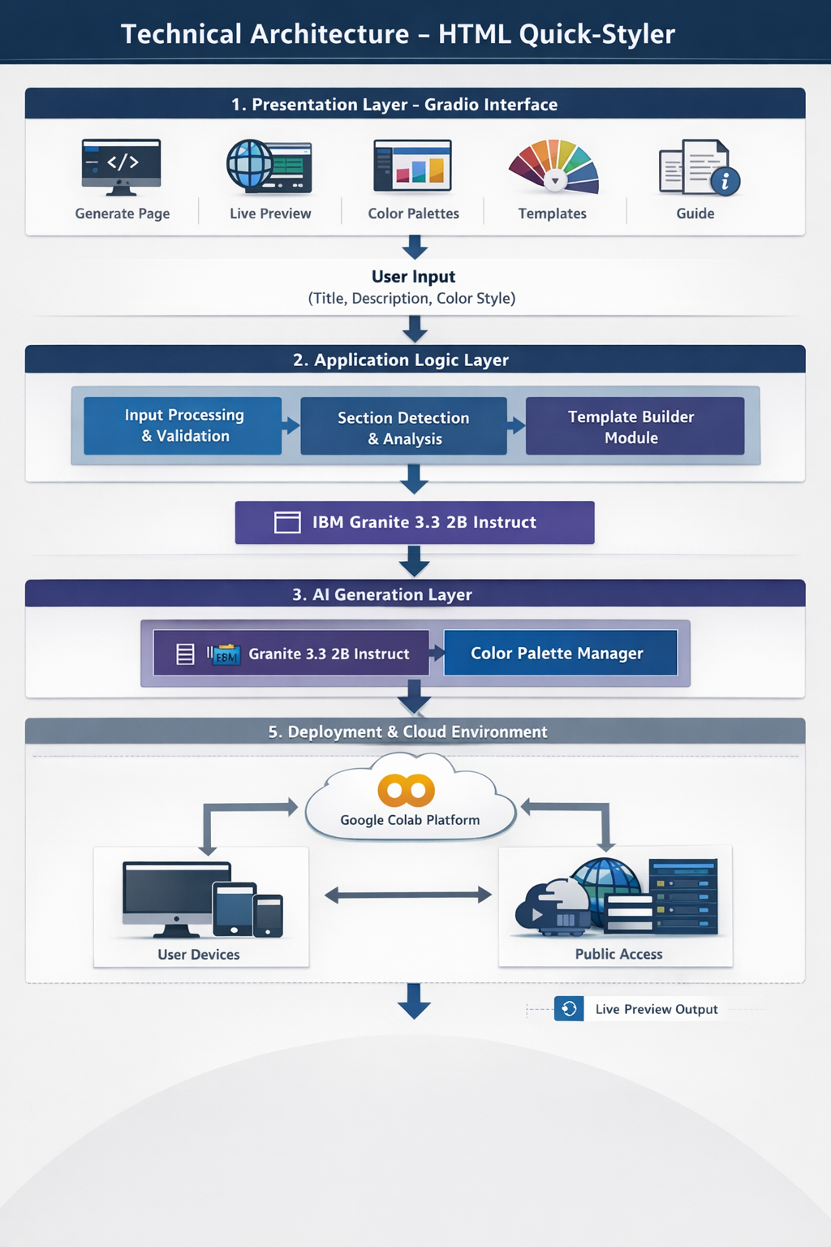

MILESTONE 1: Environment Setup & Model Configuration

Establish Google Colab environment and configure Granite model

Activity 1.1: Install Dependencies & Setup Environment
Create requirements.txt:
!pip install -q gradio

import gradio as gr
import json
import re
from datetime import datetime
from typing import Tuple, Dict, List
import random

Activity 1.2: Configure IBM Granite Model
Access Hugging Face and load model:
Model: ibm-granite/granite-3.3-2b-instruct
Colab notebook:
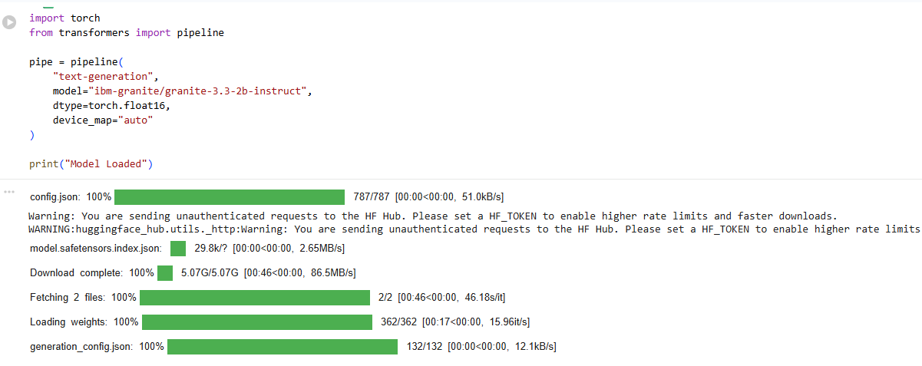
Code reference (hint: click on image and you can copy paste from Comment)
MILESTONE 2: Core Application Development
Activity 2.1: Color Palette Generator Implementation
Create ColorPaletteGenerator class with 8 predefined color schemes:
import gradio as gr
import re
def generate_html(user_requirement):
prompt = f"""You are an expert web developer. Generate a complete, modern, responsive HTML page for the following requirement.
The page MUST include:
- A <style> block with beautiful CSS (clean fonts, colors, padding, layout)
- Proper HTML structure (<!DOCTYPE html>, <html>, <head>, <body>)
- Only output raw HTML code, no explanations, no markdown, no code fences.

User Requirement:
{user_requirement}
Output only the HTML:"""
result = pipe(
prompt,
max_new_tokens=900,
do_sample=False,
temperature=None,
top_p=None,
)
full_text = result[0]["generated_text"]
# Extract only the HTML part after the prompt
generated = full_text[len(prompt):].strip()
# Strip markdown code fences if present
generated = re.sub(r"^```html\s*", "", generated, flags=re.IGNORECASE)
generated = re.sub(r"```$", "", generated).strip()
# Find real HTML start
match = re.search(r"(<!DOCTYPE html.*|<html.*)", generated, re.IGNORECASE | re.DOTALL)
if match:
generated = generated[match.start():]
return generated, generated
css = """
/* ── PAGE & FONT ── */
body {
background: #f5f7fa !important;
font-family: 'Segoe UI', sans-serif;
}
/* ── MAIN CONTAINER ── */
.gradio-container {
max-width: 1000px !important;
margin: 0 auto !important;
background: #f5f7fa !important;
}
/* ── TITLE ── */
h1 {
font-size: 2rem !important;
font-weight: 800 !important;
color: #1e293b !important;
text-align: center !important;
padding: 28px 0 4px !important;
letter-spacing: -0.5px !important;
}
/* ── SUBTITLE / DESCRIPTION ── */
.gr-prose p, .prose p {
text-align: center !important;
color: #64748b !important;
font-size: 0.95rem !important;
}
/* ── PANELS / BLOCKS ── */
.gr-block, .gr-form, .gr-box,
.gr-panel, [class*="block"], .block {
background: #ffffff !important;
border: 1px solid #e2e8f0 !important;
border-radius: 12px !important;
box-shadow: 0 2px 8px rgba(0,0,0,0.05) !important;
}
/* ── LABELS ── */
label span, .gr-block label {
color: #374151 !important;
font-weight: 600 !important;
font-size: 0.82rem !important;
text-transform: uppercase !important;
letter-spacing: 0.06em !important;
}
/* ── TEXTBOX INPUT ── */
textarea, input[type="text"] {
background: #f8fafc !important;
border: 1.5px solid #e2e8f0 !important;
border-radius: 10px !important;
color: #1e293b !important;
font-size: 0.92rem !important;
padding: 12px 14px !important;
transition: border-color 0.2s !important;
}
textarea:focus, input[type="text"]:focus {
border-color: #6366f1 !important;
box-shadow: 0 0 0 3px rgba(99,102,241,0.12) !important;
outline: none !important;
}
/* ── CODE OUTPUT BOX ── */
code, pre, .code-highlight, [class*="code"] {
background: #f1f5f9 !important;
color: #1e293b !important;
border: 1px solid #e2e8f0 !important;
border-radius: 10px !important;
font-family: 'Courier New', monospace !important;
font-size: 0.82rem !important;
}
/* ── GENERATE BUTTON ── */
button.primary, .gr-button-primary, button[variant="primary"] {
background: linear-gradient(135deg, #6366f1, #4f46e5) !important;
color: #ffffff !important;
border: none !important;
border-radius: 10px !important;
font-weight: 700 !important;
font-size: 0.95rem !important;
padding: 12px 28px !important;
box-shadow: 0 4px 16px rgba(99,102,241,0.35) !important;
transition: transform 0.15s, box-shadow 0.15s !important;
cursor: pointer !important;
}
button.primary:hover, .gr-button-primary:hover {
transform: translateY(-2px) !important;
box-shadow: 0 8px 24px rgba(99,102,241,0.45) !important;
}
/* ── SECONDARY BUTTON ── */
button.secondary, .gr-button-secondary {
background: #ffffff !important;
color: #374151 !important;
border: 1.5px solid #e2e8f0 !important;
border-radius: 10px !important;
font-weight: 600 !important;
}
/* ── TABS (if any) ── */
.tabs button, .tab-nav button {
color: #64748b !important;
background: transparent !important;
border-bottom: 2px solid transparent !important;
}
.tabs button.selected, .tab-nav button.selected {
color: #6366f1 !important;
border-bottom: 2px solid #6366f1 !important;
}
/* ── HTML PREVIEW AREA ── */
.gr-html, [class*="html"] {
background: #ffffff !important;
border: 1.5px solid #e2e8f0 !important;
border-radius: 12px !important;
padding: 0 !important;
overflow: hidden !important;
}
/* ── FOOTER ── */
footer {
display: none !important;
}
/* ── SCROLLBAR ── */
::-webkit-scrollbar { width: 6px; height: 6px; }
::-webkit-scrollbar-track { background: #f1f5f9; border-radius: 10px; }
::-webkit-scrollbar-thumb { background: #cbd5e1; border-radius: 10px; }
::-webkit-scrollbar-thumb:hover { background: #94a3b8; }
"""
with gr.Blocks(css=css, title="AI HTML Quick Styler") as interface:

gr.Markdown("# 🎨 AI Powered HTML Quick Styler")
gr.Markdown("Describe what HTML page you want and get a **styled, ready-to-use** result instantly.")
with gr.Row():
with gr.Column(scale=1):
user_input = gr.Textbox(
lines=5,
placeholder="e.g. A product landing page for a coffee brand with a hero section and pricing cards",
label="📝 Describe Your Page"
)
generate_btn = gr.Button("✨ Generate HTML", variant="primary")
with gr.Column(scale=1):
html_code = gr.Code(
language="html",
label="📄 Generated HTML Code",
lines=10
)
with gr.Row():
preview = gr.HTML(label="🖥️ Live Preview")
generate_btn.click(
fn=generate_html,
inputs=user_input,
outputs=[html_code, preview]
)
gr.Markdown("---\n*Powered by IBM Granite 3.3 2B Instruct via HuggingFace Transformers*")
interface.launch(share=True)
The ColorPaletteGenerator class provides cohesive color palettes for different design styles including modern, vibrant, ocean, forest, sunset, luxury, creative, and minimal. Each palette includes primary, secondary, accent, background, surface, text primary, text secondary, and border colors optimized for dark theme interfaces.

MILESTONE 4: Deployment

Activity 4.1: Google Colab Deployment
Launch the application in Google Colab:
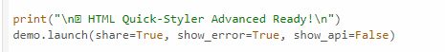
Code reference (hint: click on image and you can copy paste from Comment)
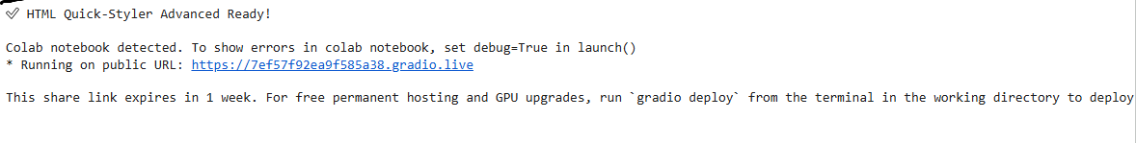
Code reference (hint: click on image and you can copy paste from Comment)
The application will be accessible via:
Public Url:
MILESTONE 5: Testing & Validation

Activity 5.1: Functional Testing
Test Case 1: Portfolio Website Generation
Input:
• Title: Modern Portfolio Website
• Description: Hero section with welcome message, features list with 3 items, about section, portfolio gallery, testimonials, contact form, and footer
• Color Style: modern

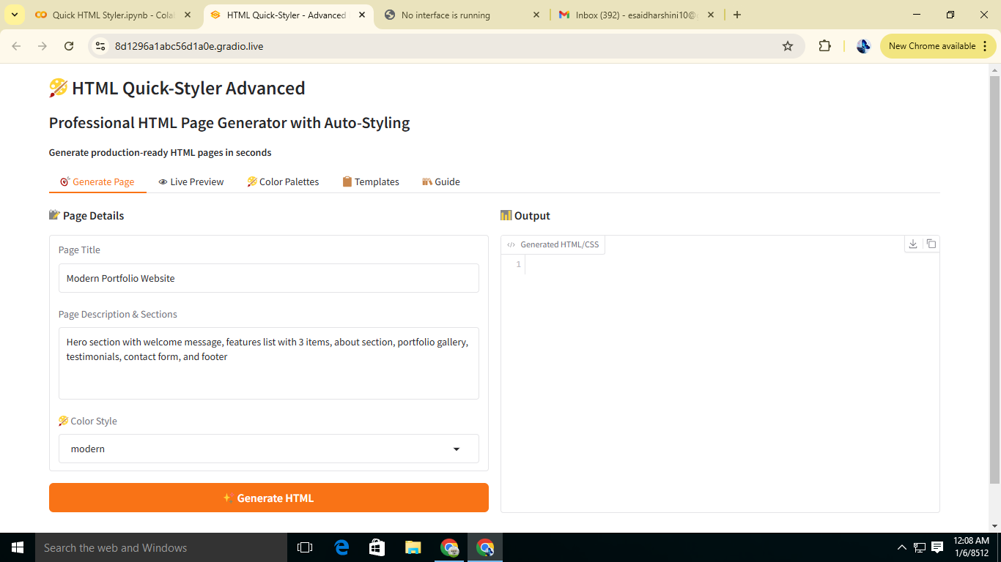

Expected Output:
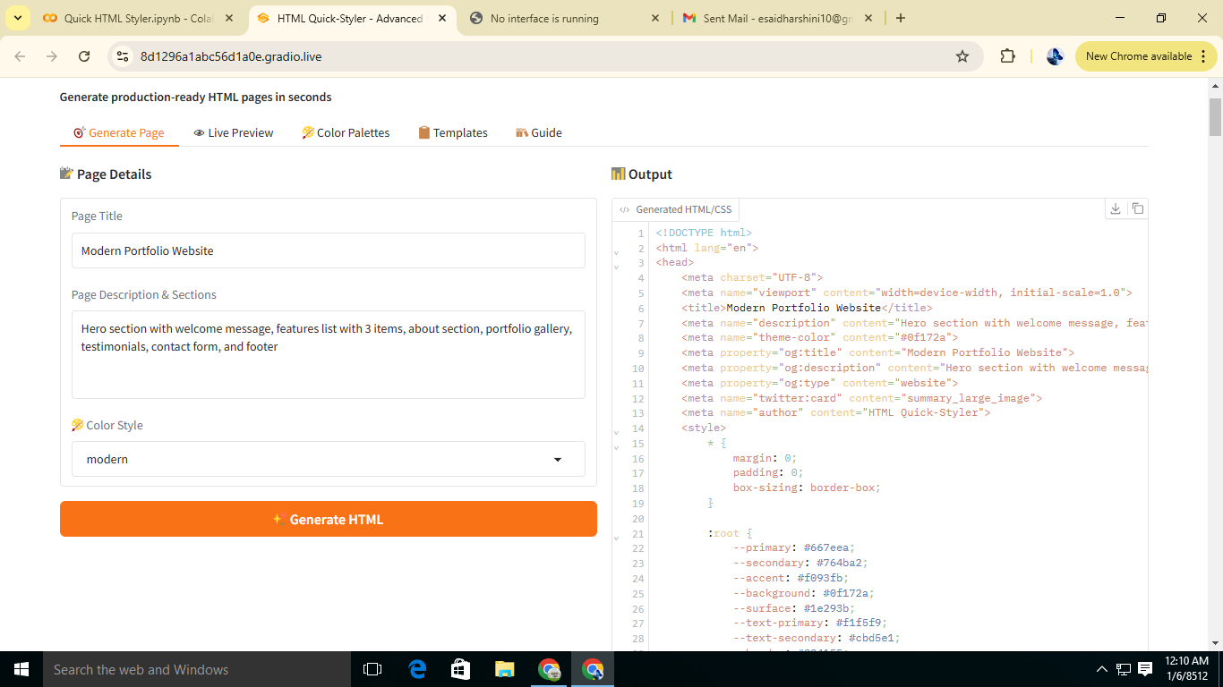

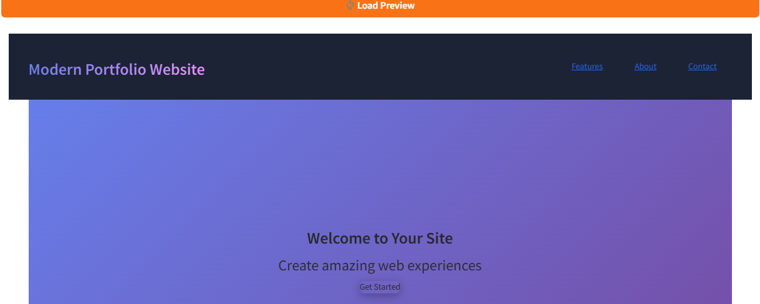

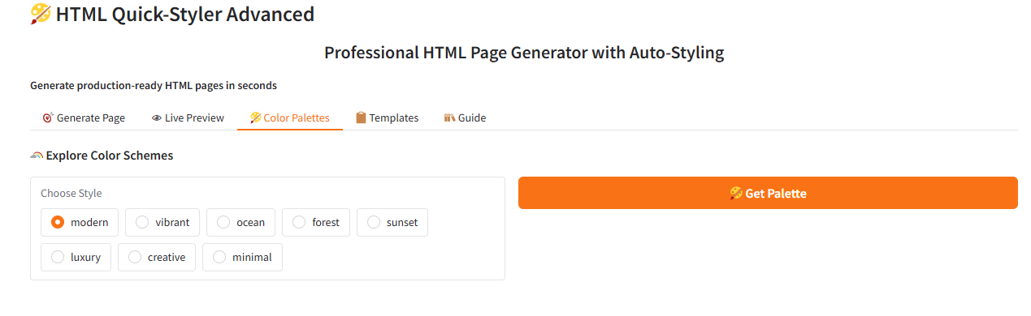

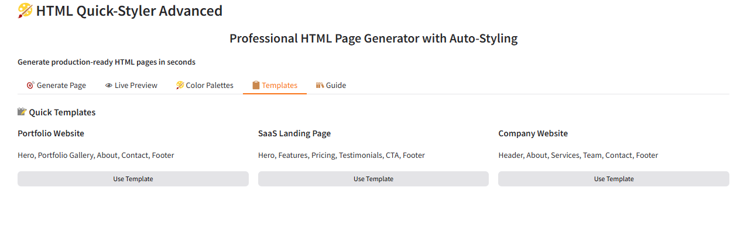

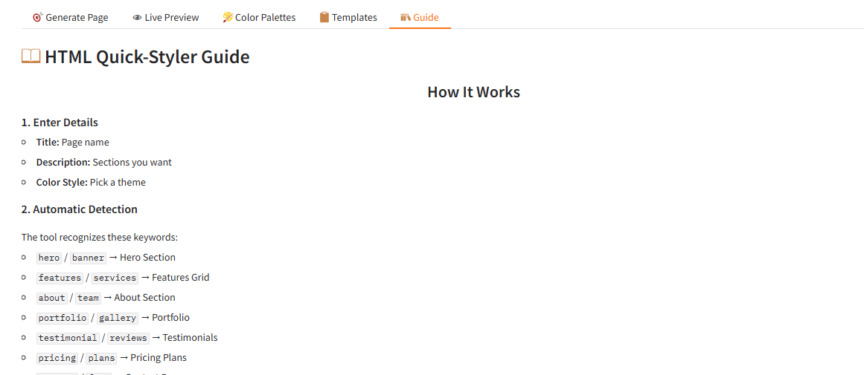

Conclusion
HTML Quick-Styler successfully delivers an intelligent web page generation platform that combines IBM Granite 3.3 2B Instruct model capabilities with Gradio's intuitive interface and Google Colab's cloud infrastructure. The modular architecture consisting of the ColorPaletteGenerator, HTMLPageBuilder, and CSS Generation Engine ensures that each component performs efficiently while transforming plain-language descriptions into production-ready HTML and CSS code within seconds. With eight curated color palettes, intelligent section detection, and comprehensive template options, the platform consistently produces professional, responsive, and visually polished web pages across all major use cases.
The testing phase confirmed that the system handles a wide range of scenarios including portfolio websites, SaaS landing pages, corporate websites, and custom color palette exploration with accurate and well-structured output every time. The deployment via Google Colab with a public Gradio URL further validates that the platform is immediately usable by real users without requiring any local installation or technical setup, making professional web design accessible to designers, developers, and non-technical users alike.
Looking ahead, HTML Quick-Styler provides a strong foundation for future enhancements such as JavaScript interactivity generation, expanded section template libraries, integration with popular frameworks like React and Tailwind CSS, and one-click export to hosting platforms like GitHub Pages and Netlify. These additions would further extend the platform's value and reach, solidifying its position as a practical and powerful AI-assisted web development tool for a wide audience of creators and businesses.

